Enhanced Security Implementation – IP-Based Access Control & System Upgrades

1. IP-Based Access Control (Core Security Layer)
- Implemented strict IP-based login restriction.
- Each user can now access the system only from pre-authorized IP addresses.
- Unauthorized access attempts are automatically blocked at login level.

2. Intelligent Multi-Layer Security Enforcement
- Security is enforced at two critical levels:
  - Login Level (Credential + IP Validation)
  - Application Level (Global Request Validation)
- Ensures protection even against:
  - Direct URL access
  - Page refresh attempts
  - Session misuse

3. Admin-Controlled IP Management Panel
- Developed a centralized User IP Management Interface.
- Key capabilities:
  - View all users with their allowed IPs
  - Add multiple IPs per user directly from grid
  - Select and remove specific IPs (multi-select support)
- Designed with a clean, intuitive UI for efficient administration

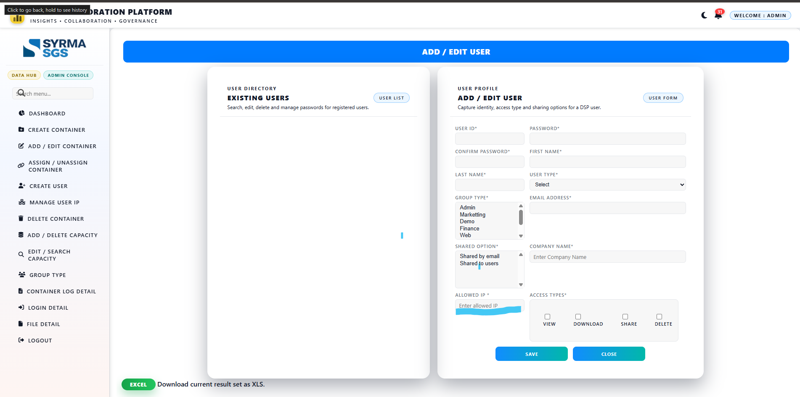
At the time of user onboarding, the administrator pre-defines authorized IP address(es), enabling strict access control right from the first login.
4. Dynamic IP Handling (Real-World Compatibility)
- Supports multiple IP entries per user to handle dynamic ISP environments.
- Allows seamless updates without impacting user access continuity.

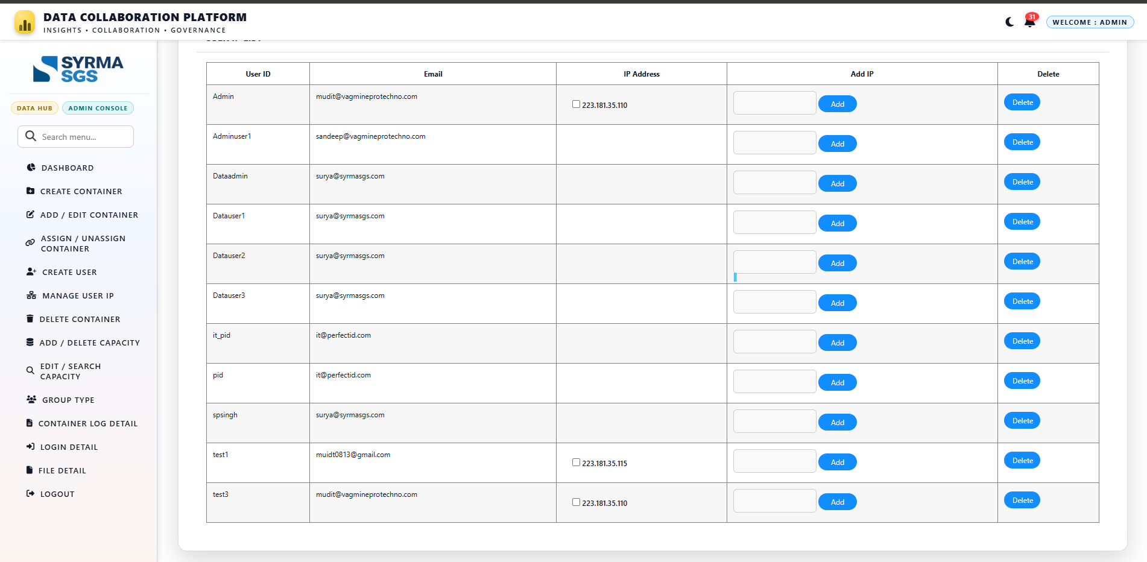
5. User IP Management
• Admin can add and remove IP addresses directly from the Manage User IP page.
• Multiple IPs can be managed easily for each user.
• Provides a centralized interface to control and update user access as needed.
6. Performance Optimization with Smart Caching
- Implemented caching mechanism for IP validation.
- Ensures fast access checks with minimal database load.
- Includes automatic cache refresh on IP updates.

7. Duplicate Prevention & Data Integrity
- Prevented duplicate IP entries at both application and database levels.
- Ensures clean, consistent, and reliable data.

8. Role-Based Security Flexibility
- Admin users are exempted from IP restrictions to avoid accidental lockouts.
- Regular users remain fully secured under IP validation.

9. Login Security Enhancements
- Integrated IP validation with existing authentication flow.
- Combined with OTP-based login verification for multi-factor security.

10. Thorough Testing & Validation
- Successfully tested across multiple scenarios:
  - Valid IP access ✔
  - Unauthorized IP blocking ❌
  - Multiple IP handling ✔

